Human vs AI Responses: A Statistical Comparison of Linguistic Characteristics

- Introduction

Artificial intelligence has become a common part of our daily lives, especially for answering questions and generating text. AI systems such as ChatGPT can produce responses that are similar to responses written by humans. This raises an interesting question: are there measurable differences between human-written and AI-generated responses?

In this project, I compare human-written and AI-generated responses using a dataset containing responses from both humans and ChatGPT. I focus on some simple characteristics of the responses, such as their length, number of sentences, average sentence length, vocabulary diversity, and punctuation usage.

The aim of this project is not to determine whether a particular response was written by a human or AI. Instead, the aim is to understand whether these two types of responses show measurable differences in their writing characteristics.

- Research Question

Are there measurable differences between human-written and AI-generated responses ?

- Dataset

For this project, I used the Human–ChatGPT Comparison Corpus (HC3) dataset created by Hello-SimpleAI. The dataset contains questions along with responses written by humans and responses generated by ChatGPT.

The dataset contains 24,322 records. Each record includes a question, human responses, ChatGPT responses, and information about the source of the question.

Some records did not contain a ChatGPT response. After removing records where either a human response or a ChatGPT response was unavailable, 23,867 paired records were used for the analysis.

For each usable record, I used the first human response and the first ChatGPT response for comparison.

- Methodology

The dataset was first loaded and examined using Python. Records without either a human response or a ChatGPT response were excluded from the paired analysis. For each remaining record, the first human response and the first ChatGPT response were selected.

I then calculated five features for both types of responses:

- Response length — total number of words in the response.
- Sentence count — estimated by counting periods, exclamation marks, and question marks.
- Average sentence length — calculated as the number of words divided by the estimated number of sentences.
- Vocabulary diversity (TTR) — calculated as the number of unique words divided by the total number of words.
- Punctuation usage — calculated as the number of selected punctuation marks (., !, ?, ,, ;, :) per 100 words.
The average value of each feature was calculated for human and ChatGPT responses. Paired differences were then calculated between the two types of responses. A one-sample t-test was used on these paired differences to determine whether the average difference was statistically different from zero.

- Features Analyzed

The following five features were selected to compare human-written and AI-generated responses:

- Response Length
This measures the total number of words in a response. It helps us see whether one type of response tends to be longer than the other.

- Sentence Count
This measures the estimated number of sentences in each response.

- Average Sentence Length
This measures the average number of words in each sentence. It was calculated by dividing the total number of words by the estimated number of sentences.

- Vocabulary Diversity (TTR)
Type-Token Ratio (TTR) measures vocabulary diversity. It is calculated by dividing the number of unique words by the total number of words. A higher TTR means that a larger proportion of the words are unique.

- Punctuation per 100 Words
This measures how frequently the selected punctuation marks appear relative to the length of the response. Using punctuation per 100 words makes the comparison fairer when responses have different lengths.

- Results
6.1) Response Length
The average human response length was 147.98 words, while the average ChatGPT response length was 177.99 words. Therefore, ChatGPT responses were approximately 30.01 words longer on average.

A paired difference analysis followed by a one-sample t-test showed that this difference was statistically significant (p < 0.001).
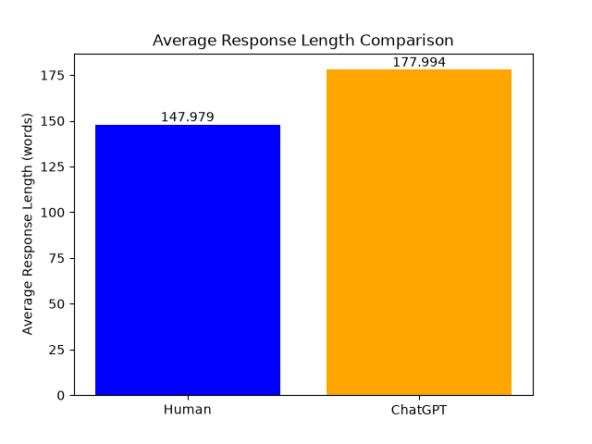

6.2) Sentence Count
The average human response contained 7.86 sentences, while the average ChatGPT response contained 8.37 sentences. This means that ChatGPT responses contained approximately 0.51 more sentences per response on average.

A paired difference analysis followed by a one-sample t-test showed that this difference was statistically significant (p < 0.001).
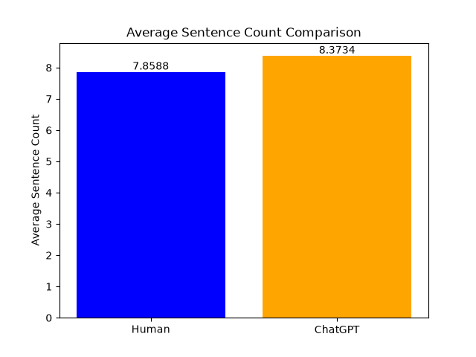

6.3) Average Sentence Length
The average human sentence contained 19.89 words, while the average ChatGPT sentence contained 21.99 words. Therefore, ChatGPT sentences were approximately 2.09 words longer on average.

A paired difference analysis followed by a one-sample t-test showed that this difference was statistically significant (p < 0.001).

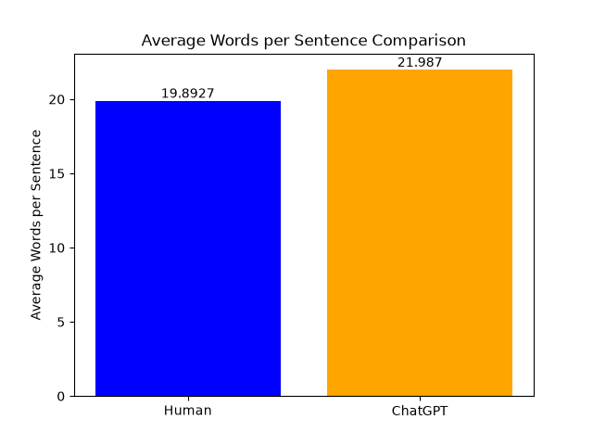

6.4) Vocabulary Diversity (TTR)
The average TTR for human responses was 0.684, while the average TTR for ChatGPT responses was 0.560. Therefore, ChatGPT responses had an average TTR approximately 0.125 lower than human responses.

A paired difference analysis followed by a one-sample t-test showed that this difference was statistically significant (p < 0.001).

However, this result should be interpreted cautiously because TTR is affected by response length. Since ChatGPT responses were longer on average, this may have influenced the TTR comparison.
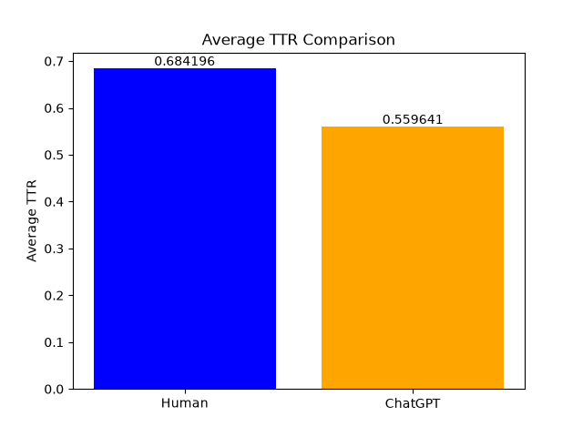

6.5) Punctuation per 100 Words
Human responses contained an average of 10.43 selected punctuation marks per 100 words, while ChatGPT responses contained 10.01. This means that ChatGPT responses used approximately 0.42 fewer punctuation marks per 100 words.

A paired difference analysis followed by a one-sample t-test showed that this difference was statistically significant (p < 0.001). However, the actual difference was relatively small, so its practical importance may be limited.

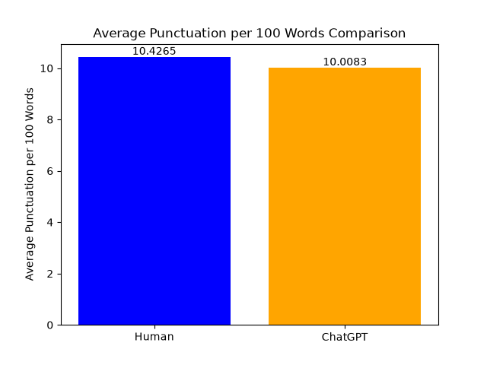

- Discussion

The results show measurable differences between human-written and ChatGPT-generated responses in the dataset used for this project.

ChatGPT responses were generally longer than human responses. They also contained slightly more sentences, and the average sentence was longer. This suggests that ChatGPT tended to provide longer responses to the questions in this dataset.

ChatGPT responses also had a lower average TTR than human responses. However, this finding should be interpreted carefully because TTR is affected by response length, and ChatGPT responses were longer on average.

For punctuation, ChatGPT responses had slightly fewer selected punctuation marks per 100 words than human responses. Although the statistical test showed a significant difference, the actual difference was small.

Overall, the findings suggest that human-written and ChatGPT-generated responses have measurable differences in several basic writing characteristics. However, these characteristics alone are not enough to conclude that a particular response was written by a human or generated by AI.

- Limitations
This project has some limitations that should be considered when interpreting the results.

- Simple sentence counting:
Sentence counts were estimated by counting periods, exclamation marks, and question marks. This is a simple approach and may sometimes incorrectly identify sentence boundaries, especially in cases involving abbreviations or decimal numbers.

- TTR and response length:
Type-Token Ratio is affected by the length of a text. Since ChatGPT responses were longer on average, response length may have influenced the TTR comparison.

- First response selection:
Each record can contain multiple human and ChatGPT responses. For simplicity, only the first available response from each category was used.

- Dataset-specific results:
The analysis was performed using the HC3 dataset. Therefore, the findings may not represent all human-written text or all AI-generated text from other AI systems and datasets.

- Conclusion

This project investigated whether there are measurable differences between human-written and AI-generated responses. Using the HC3 dataset, five writing characteristics were compared: response length, sentence count, average sentence length, vocabulary diversity, and punctuation usage.

The results showed measurable differences between human and ChatGPT responses across all five features. ChatGPT responses were generally longer, contained slightly more sentences, and had longer sentences. They also showed lower vocabulary diversity and slightly lower punctuation usage per 100 words.

Therefore, the results suggest that human-written and ChatGPT-generated responses have different measurable writing characteristics in this dataset. However, these features alone should not be treated as a reliable way to determine whether an individual response was written by a human or generated by AI.

- References

- Hello-SimpleAI. (2023). HC3: Human–ChatGPT Comparison Corpus. Hugging Face. https://huggingface.co/datasets/Hello-SimpleAI/HC3⁠�

- Python Software Foundation. Python. https://www.python.org/⁠�

- Python Software Foundation. Python Documentation. https://docs.python.org/3/⁠�

- pandas Documentation. https://pandas.pydata.org/docs/⁠�

- Matplotlib Documentation. https://matplotlib.org/stable/⁠�

- SciPy Documentation. https://docs.scipy.org/doc/scipy/⁠�

